Spcm lab 14

Khushi chauhan

B1 h

500105956

Executing Ad Hoc Commands

Steps to be followed: 1. Generate SSH key pair on the main node 2. Copy the SSH key on the other two nodes 3. Update the host file with the host IP address 4. Establish connectivity between specified hosts and the Ansible server 5. Gather System Information Using Ad-Hoc Commands

Step 1: Establish connectivity between specified hosts and the Ansible server

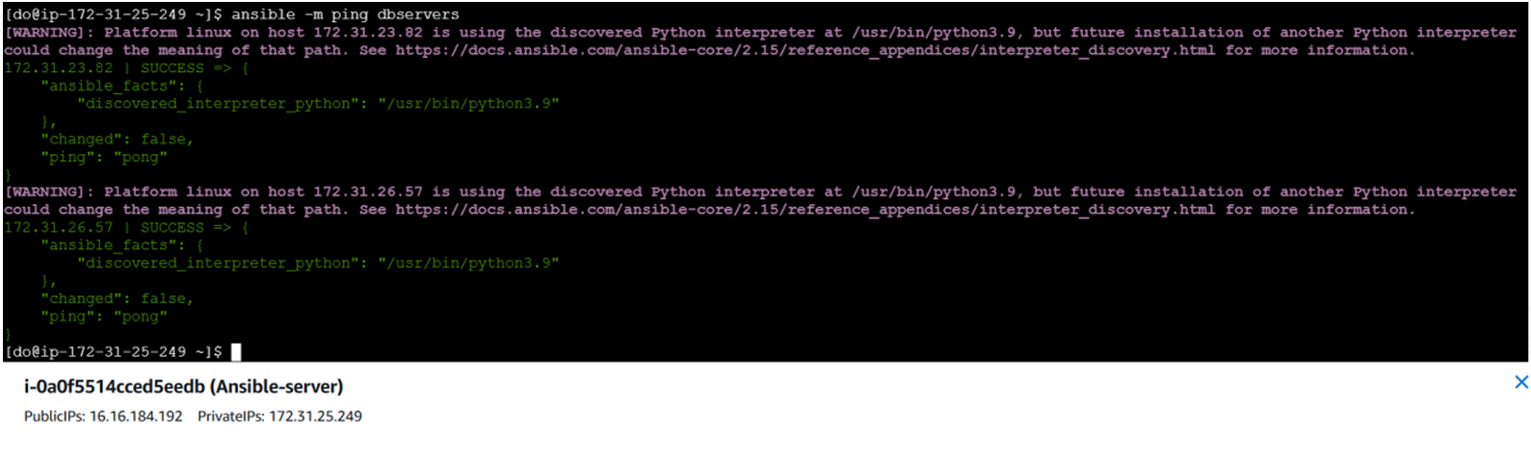

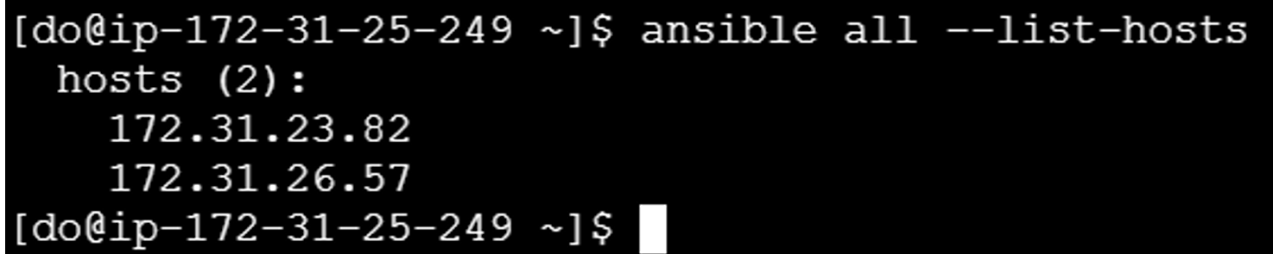

Step 2: Gather System Information Using Ad Hoc Commands

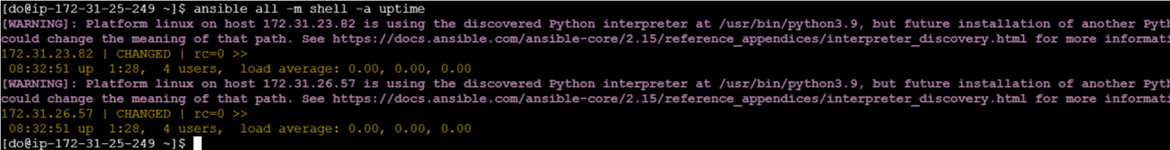

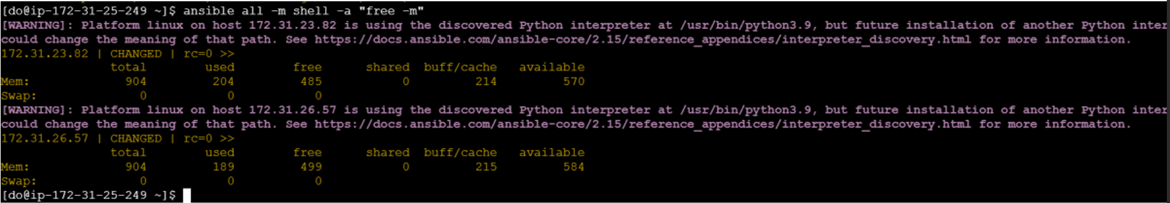

You will see that Ansible logs in to each machine in turn and runs the uptime command, returning the current uptime output. By following these steps, you have successfully demonstrated how to use ad hoc commands for quickly executing tasks on remote servers without the need for full playbooks.